**SPH3U 7.2 Radioactive Decay**

1. **Radioactivity**

|  |  |
| --- | --- |
| Radioactivity: |  |
| stable atom |  |
| atomic # |  |
| 3 types of decay |  |

1. **Alpha (α) decay**

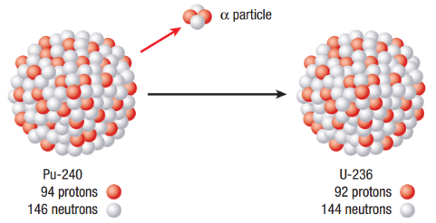

|  |  |
| --- | --- |
| Alpha decay: |  |
| α particle |  |
| plutonium-240 decay |  |
| general alpha decay |  |
| X and Y |  |

When lead-204 undergoes alpha decay, it produces a stable isotope. Determine the element and its atomic number and mass number. Write the nuclear reaction equation.

1. **Beta (β) decay**

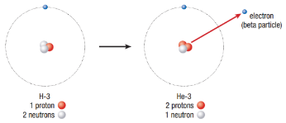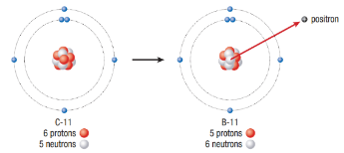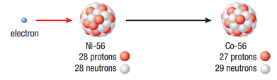

|  |  |
| --- | --- |
| Beta decay: |  |
| β particle |  |
| Beta-negative decay: |  |
| tritium H-3 decay |  |
| Beta-positive decay: |  |
| carbon-11 decay |  |
| Electron capture: |  |
| Ni-56 decay |  |

When bismuth-214 undergoes beta-negative decay, it produces a stable isotope. Determine the element and its atomic number and mass number. Write the nuclear reaction.

1. **Gamma (γ) decay**

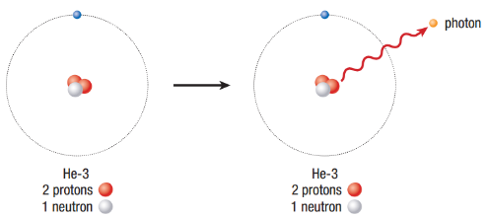

|  |  |
| --- | --- |
| Gamma decay: |  |
| γ ray |  |
| He-3 decay |  |
| general gamma decay |  |
| excited state |  |

When dysprosium-152 undergoes gamma decay, its nucleus changes from an excited state to a stable state. Write the nuclear reaction equation for this gamma decay.

1. **Characteristics of radioactive decay**

|  |  |
| --- | --- |
| Danger of radiation: |  |

|  |  |  |  |
| --- | --- | --- | --- |
| **Decay** | **Radiation** | **Electric charge** | **Penetrating ability** |
| alpha |  |  |  |
| beta-negative |  |  |  |
| beta-positive |  |  |  |
| electron capture |  |  |  |
| gamma |  |  |  |

**Homework:** page 329: #1-3, 5-6